Ideation Phase
Define the problem statement

Date | 02 NOVEMBER 2025
Team ID | NM2025TMID01366
Project Name | Laptop Request Catalog Item
Maximum Mark | 2 Marks

Customer Problem Statement
Employees face challenges when requesting laptops for work due to manual request processes.These delays lead to inefficiencies, miscommunication, and incomplete tracking of requests.
There’s also no dynamic behavior in the form to guide users, causing incorrect or incomplete data submission.An automated Service Catalog Item with smart form behavior and approval tracking would ensure faster, error-free requests and improved user experience.
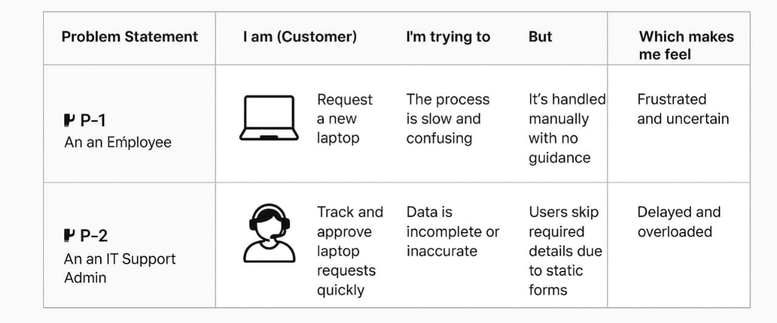

Problem Statement PS-1
As an employee, I am trying to request a laptop needed for my work, but the current process is manual and time-consuming. Because there is no automated form or clear guidance, I often make mistakes or forget required details.
This makes me feel frustrated and anxious about whether my request will be approved on time. I need an easy, dynamic service catalog form that guides me and ensures all necessary information is filled correctly.

Problem Statement PS-2
As an IT Support Admin, I want to process laptop requests efficiently, but due to incomplete or incorrect user data, approvals get delayed. Because the form lacks validation and dynamic behavior, I spend extra time clarifying missing information.
This makes me feel overwhelmed and reduces overall service efficiency. I need an automated system with UI policies and actions to validate data, speed up processing, and maintain accurate records.

